**Course10-micro:bit voice talk**

****Learning goals:****

This lesson learns to use Python programming to let the micro:bit emit a voice.

**Code：**

from microbit import *

import speech

display.show(Image.HAPPY)

speech.say("Hi, I'm an excellent robot from China.")

In the program,import speech is means to import the speech library function, use the speech.say function in the library to play "Hi, I'm an excellent robot from China".

"Hi, I'm an excellent robot from China" Change to whatever you want to play.

**Programming and downloading：**

1. You should open the Mu software, and enter the code in the edit window, , as shown in Figure 10-1.

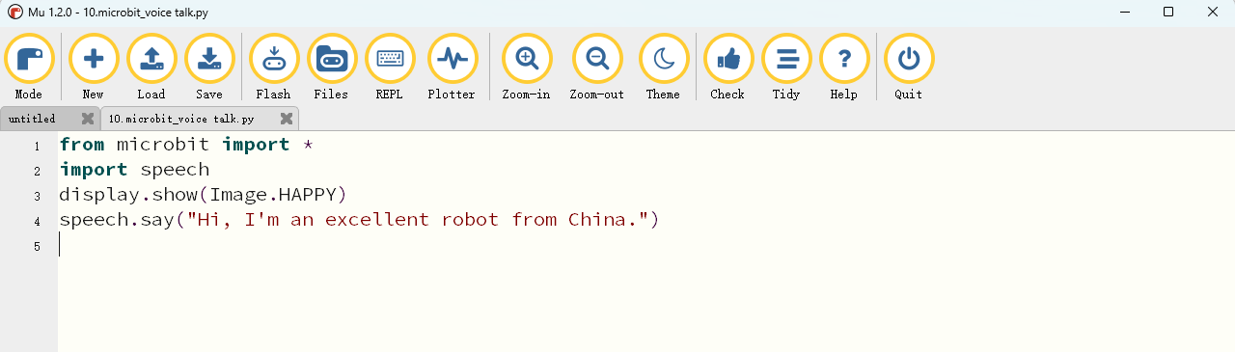

Figure 10-1

2.As shown in Figure 10-2, you need to click the Check button to check if our code has an error. If a line appears with a cursor or an underscore, the program indicating this line is wrong.

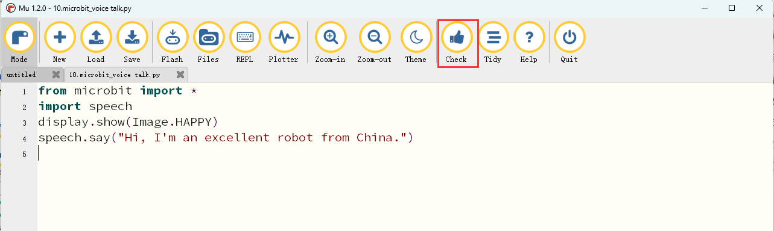

Figure 10-2

3.You need to connect the micro data cable to micro:bit and the computer, then click the Flash button to download the program to micro:bit as shown in Figure 10-3.

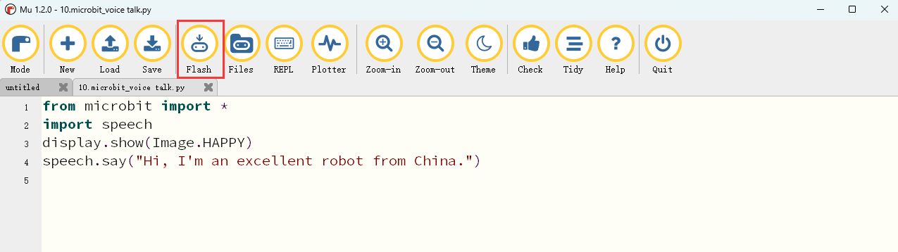

Figure 10-3

4.After downloading the program into micro:bit, you can see a smiley face on the robot's dot matrix and make a sound: Hi, I'm an excellent robot from China.

We need to use headphones or speakers to hear the sound. The two wiring methods are as shown below.

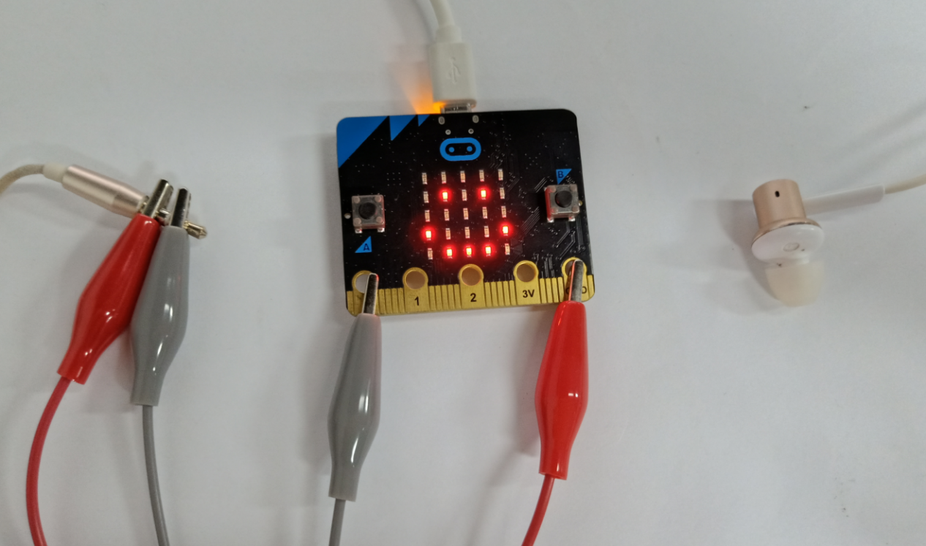

Figure 10-4

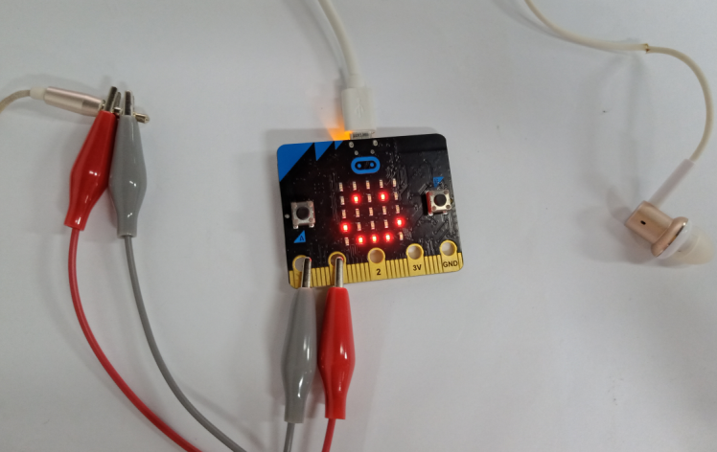

Figure 10-5

**Headphone interface:**

